Instructions for Use of the SAS and SPSS Versions
of the ED Classification Algorithm

Background/Introduction

With support from the Commonwealth Fund, the Robert Wood Johnson Foundation, and the United Hospital Fund of New York, the NYU Center for Health and Public Service Research has developed an algorithm to help classify ED utilization. The algorithm was developed with the advice of a panel of ED and primary care physicians, and it is based on an examination of a sample of almost 6,000 full ED records. Data abstracted from these records included the initial complaint, presenting symptoms, vital signs, medical history, age, gender, diagnoses, procedures performed, and resources used in the ED. Based on this information, each case was classified into one of the following categories:
- Non-emergent - The patient’s initial complaint, presenting symptoms, vital signs, medical history, and age indicated that immediate medical care was not required within 12 hours;
- Emergent/Primary Care Treatable - Based on information in the record, treatment was required within 12 hours, but care could have been provided effectively and safely in a primary care setting. The complaint did not require continuous observation, and no procedures were performed or resources used that are not available in a primary care setting (e.g., CAT scan or certain lab tests);
- Emergent - ED Care Needed - Preventable/Avoidable - Emergency department care was required based on the complaint or procedures performed/resources used, but the emergent nature of the condition was potentially preventable/avoidable if timely and effective ambulatory care had been received during the episode of illness (e.g., the flare-ups of asthma, diabetes, congestive heart failure, etc.); and
- Emergent - ED Care Needed - Not Preventable/Avoidable - Emergency department care was required and ambulatory care treatment could not have prevented the condition (e.g., trauma, appendicitis, myocardial infarction, etc.).

This information that was used to develop the algorithm required analysis of the full medical record. Since such detailed information is not generally available on computerized ED or claims records, these classifications were then “mapped” to the discharge diagnosis of each case in our sample to determine for each diagnosis the percentage of sample cases that fell into these four categories. For example, patients discharged with a final diagnosis of “abdominal pain” may include both patients who arrived at the ED complaining of stomach pain, as well as those who reported chest pain (an a possible heart attack). Accordingly, for abdominal pain, the algorithm assigns a specific percentage of the visit into the categories of “non-emergent”, “emergent/primary care treatable”, and “emergent/ED care needed-not preventable/avoidable” based on what we observed in our sample for cases with an ultimate discharge diagnosis of abdominal pain.

It is important to recognize that the algorithm is not intended as a triage tool or a mechanism to determine whether ED use in a specific case is “appropriate” (e.g., for reimbursement purposes). Since few diagnostic categories are clear-cut in all cases, the algorithm assigns cases probabilistically on a percentage basis, reflecting this potential uncertainty and variation.

Since the original development of the algorithm, users have expressed an interest in examining separately cases involving a primary diagnosis of injury, mental health problems, alcohol, or substance abuse. Accordingly, we have pulled these conditions out of the standard classification scheme, and tabulate them separately. There are also a residual of conditions (approximately 15%) where our sample was not of sufficient size to assign percentages for the standard classification - these conditions are also tabulated separately. See the attachment for schematic diagram of algorithm.

Applying the Algorithm to an ED Data Base

The computer programming that applies the algorithm is contained in the following files.

For the SPSS version, the files are:
- “DX GROUPS.SAV” - This file is merged onto your ED data in order to recode and group diagnoses;
- ‘EDDXS.SAV" - This file lists diagnoses and the proportion of cases that are to be assigned to the classification categories; and
- “ED Algorithm.sps” - This is the SPSS program that is used to run the algorithm.

For the SAS version (which will run in either SAS 7 or SAS 8), the files are:
- “ED Macros.sas” - This file contains SAS macros that group or recode diagnoses and classify them into the categories described above;
- ‘FINDXACS.SD7" - This file lists diagnoses and the proportion of cases that are to be assigned to the classification categories; and
- “ED Algorithm Sample Program.sas” - This is the SAS program that is used to run the algorithm.
All files are contained in the compressed (zipped) file. Applying the algorithm involves three simple steps:

STEP 1: Put the unzipped files in a directory along with the ED encounter data set you want to classify (containing one record for each ED visit). The ED data set should be in the appropriate format (SAS 7 or 8, or SPSS) and contain a variable with the principal discharge diagnosis for the ED visit. The principal diagnosis variable should be in character or string format, left-justified, with leading zeroes (where appropriate), and WITHOUT an embedded decimal.
STEP 2: Set the appropriate names in the LET statements at the top of the program.
For the SPSS version, specify the following: 1) IN SINGLE QUOTES, the full path name (including a final backslash) of the directory on your computer that contains the files, 2) IN SINGLE QUOTES, the name of the SPSS data set (including the .SAV extension) containing ED records to be classified, 3) the name of the variable in your data set that contains the principal diagnosis, and 4) IN SINGLE QUOTES, the name you want the program to use to write the output data set (including the .SAV extension).
For the SAS version, specify the following: 1) the full path name of the directory on your computer that contains the files (which will be used as the LIBNAME for the run), 2) the name of the data set to be classified (without its libname prefix), and 3) the name of the variable in your data set that contains the principal diagnosis
STEP 3: Run the program and analyze the output data set, which will be written to the same directory the other files are in.

The output data set will simply add a new set of variables to your original data set - the names of the new variables are:
- ne = “Non-emergent”
- epct = “Emergent/Primary Care Treatable”
- edcnpa = “Emergent - ED Care Needed - Preventable/Avoidable”
- edcnnpa = “Emergent - ED Care Needed - Not Preventable/Avoidable”
- injury = “Injury principal diagnoses”
- psych = “Mental health principal diagnoses”
- alcohol = “Alcohol-related health principal diagnoses”
- drug = “Drug-related health principal diagnoses (excluding alcohol)”
- unclassified = “Not classified - not in one of the above categories”

For each ED encounter, the numbers in the new fields represent the relative percentage of cases for that diagnosis falling into the various classification categories. For example, in the case of urinary tract infections (ICD-9-CM code 599.0), each case is assigned 66% “non-emergent”, 17% “emergent/primary care treatable”, and 17% “emergent - ED care needed - preventable/avoidable”. The sum of the data new data fields will always total 1", and the injury, psych, alcohol, drug, and unclassified fields are always binary (equal to 1" or 0"). To profile a hospital, payor group, zip code area, patient type, etc., simply aggregate these values to find the total percentage of cases falling into each of the categories.

For more information on how these categories were constructed, please consult the articles on our website, at http://www.nyu.edu/wagner/chpsr/index.html?p=62.

Questions or Problems?

To resolve any questions or problems you have in running the algorithm or analyzing the output, please contact Tod Mijanovich at tm11@nyu.edu.
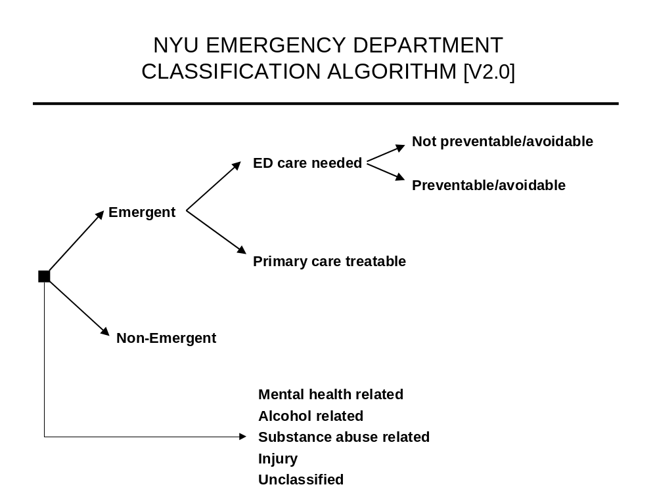
ATTACHMENT

